|  |  |
| --- | --- |
|  | **2025**  **DA3 Outcome 2 - SAT 1**  VCE Data Analytics , Unit 3 |

**Data Analytics Unit 3, Outcome 2, SAT - Part 1**

Name: _Abdallah El Sayed_____________________ Marks: ______ /100

**Assessment policy:** 20% of the maximum available score is deducted if a task is completed late (unexcused) within one week after the actual date. After one week the mark of zero will be permanent.

|  |  |  |  |  |  |  |
| --- | --- | --- | --- | --- | --- | --- |
| School-assessed Task  The student’s level of achievement in Unit 3, Outcome 2 and in Unit 4, Outcome 1 will be assessed through a School-assessed Task.  The School-assessed Task contributes 30 per cent to the study score.   | Outcomes | Assessment tasks | | --- | --- | | **Unit 3**  **Outcome 2**  Propose a research question, formulate a project plan, collect and prepare data, and generate design ideas and a preferred design for creating infographics and/or dynamic data visualisations. | A documented research question and a project plan (Gantt chart) indicating tasks, times, milestones, dependencies and the critical path  **AND**  An analysis that defines the requirements, constraints and scope of infographics and/or dynamic data visualisations  **AND**  A collection of complex data sets that has been referenced  **AND**  A folio of design ideas and evaluation criteria  **AND**  Detailed design specifications of the preferred design.  Time allocated should be at least 8–10 weeks of class time. | | **Unit 4**  **Outcome 1**  Develop and evaluate infographics and/or dynamic data visualisations that meet requirements and assess the effectiveness of the project plan. | Infographics and/or dynamic data visualisations that present findings in response to a research question  **AND**   * an evaluation of the efficiency and effectiveness of infographics and/or dynamic data visualisations * an assessment of the effectiveness of the project plan (Gantt chart) in monitoring project progress   in one of the following:   * a written report * an annotated visual plan.   Time allocated should be at least 8 weeks of class time. | |

Area of Study 2 Data analytics: analysis and design

In this area of study, students independently determine and propose a research question and collect and analyse data from both primary and secondary sources. This is the first part of the School-assessed Task, involving analysis and design, with the second part undertaken in Unit 4, Area of Study 1.

Students prepare a project plan that includes both student-determined and teacher-provided milestones in a Gantt chart that includes all stages of the problem-solving methodology covered in Unit 3, Area of Study 2 and in Unit 4, Area of Study 1. Throughout Unit 3, Area of Study 2 and Unit 4, Area of Study 1, students monitor and modify their project plans as required. They do not have to use dedicated project management software.

A range of methods is used to collect data to determine solution requirements, constraints and scope. Primary and secondary data is then collected to address the research question using appropriate methods and considering legal requirements. The scope of the research question should be sufficiently detailed to not require a simple yes or no answer, but rather an exploration of the data collected.

Students generate and document two to three design ideas for creating the infographics and/or dynamic data visualisations using ideation tools. Evaluation criteria are developed by the students to determine which of the ideas will be used as the basis of the preferred design. These ideas are then fully developed into detailed designs using a range of design tools addressing the appearance, usability and functionality of the solution. These evaluation criteria will be used in Unit 4, Area of Study 1 to evaluate the efficiency and effectiveness of the infographics and/or dynamic data visualisations.

Students apply computational thinking skills when determining data requirements associated with a research question and apply design thinking skills when designing infographics and/or dynamic data visualisations.

Outcome 2

On completion of this unit the student should be able to propose a research question, formulate a project plan, collect and prepare data, and generate design ideas and a preferred design for creating infographics and/or dynamic data visualisations.

To achieve this outcome the student will draw on key knowledge and key skills outlined in Area of Study 2.

|  |  |
| --- | --- |
| Key knowledge   * features of a research question, including: * clarity * measurability of data requirements * feasibility * originality * features of project management to develop a project plan using Gantt charts, including: * identification of tasks * sequencing of tasks * time allocation * dependencies * milestones * critical path * monitoring and documenting the progress of projects * characteristics of functional and non-functional requirements, constraints and scope, including data to address the research question * methods for collecting primary data, including: * surveys * interviews * observations * methods for collecting secondary data, including: * querying of data stored in large repositories * online searches * characteristics of data types and data structures relevant to manipulating collected data * suitability of quantitative and qualitative data for manipulation to prepare for data visualisations, including: * coding of qualitative data * identifying trends, relationships and patterns * characteristics of data integrity, including: * accuracy * authenticity * correctness * reasonableness * relevance * timeliness * procedures and techniques for the ethical collection of primary data, including: * using participant information statements and/or consent forms * de-identifying personal data | * key legal requirements for the protection of intellectual property and the collection, communication and security of data and information, including: * Copyright Act 1968 (Cwlth) * Health Records Act 2001 (HPP 1, 2, 4) * *Privacy Act 1988* (Cwlth) (APP 3, 4, 5, 6, 11) * Privacy and Data Protection Act 2014 (IPP 1, 2, 4, 10) * methods for referencing secondary sources using the APA referencing system to acknowledge intellectual property, including: * use of citations * creation of reference lists * procedures and techniques for managing data, including: * archiving * backups (full, incremental, differential) * disposal * ideation techniques and tools for generating design ideas, including: * mood boards * brainstorming * mind maps * sketches * annotations * design principles that influence the appearance and functionality of infographics and dynamic data visualisations, including: * alignment * balance * contrast * image use * space * text and table formatting * usability * navigation * interactivity * criteria for evaluating design ideas and the efficiency and effectiveness of infographics and dynamic data visualisations * design tools for generating solution designs from design ideas, including: * storyboards * mock-ups * input-process-output (IPO) charts * query designs. |

|  |
| --- |
| Key skills   * propose a research question * create, monitor and modify project plans using software * analyse and document solution requirements, constraints and scope of infographics and/or dynamic data visualisations * apply techniques for searching, collecting, referencing and managing data sets * generate design ideas using appropriate ideation techniques and tools * develop evaluation criteria for design ideas and the efficiency and effectiveness of infographics and dynamic data visualisations * produce detailed designs using appropriate design principles and tools. |

|  |  |  |  |  |
| --- | --- | --- | --- | --- |
| **2025 SAT Part 1** Unit 3 Outcome 2  Marking Scheme, Deliverable dates, Criteria  *Dates Subject to change | | **Schoolbox**  **Mark**  **%** | **Student Score** | **Comments**  *\*Refer to the VCAA SAT Rubric for marking criteria and performance indicators* |
| **Criteria 1**  **C1**  **SAT1**   |  | | --- | | **Week 2**, **T2** | | Documents a comprehensive research question as an information problem.  Documents comprehensively evidence of critical and creative thinking through the identification, clarification and the critical analysis of the sources and the data to be collected. | **10** |  | **Skills in developing a**  **research question.**    **Submit an initial Analysis of your project needs.** |
| **Criteria 2**  **C2**  **SAT1**   |  | | --- | | **Week 2, T2** | | Prepares a Gantt chart using software that comprehensively documents all the stages and activities of the problem-solving methodology for U3 O2 and U4 O1.  Documents comprehensively all relevant tasks, sequencing, time allocation, milestones, dependencies and the critical path for the project. | **20** |  | **Skills in project**  **management.**  **Submit a Gantt Chart which is unique to your project activities.** |
| **Criteria 3**  **C3**  **SAT1**   |  | | --- | | **Week 3, T2** | | Documents comprehensively all the data used to support the research question.  Documents comprehensively all the functional and non-functional solution requirements, constraints and scope.  Documents comprehensively evidence of critical and creative thinking through the use of effective  questions and strategies to critically analyse solution requirements. | **15** |  | **Skills in**  **documenting**  **analysis.**  **Submit an exact, precise & detailed Analysis of your project needs (design Brief Doc).** |
| **Criteria 4**  **C4**  **SAT1**   |  | | --- | | **Week 4, T2-**  **Week 7, T2** | | Acquires a comprehensive collection of data sets from both primary and secondary data sources using appropriate data acquisition methods.  Comprehensive preparation of all data for manipulation including data types and data structures.  References a comprehensive set of primary and secondary data using the APA referencing system and applying conventions consistently. | **30** |  | **Skills in data**  **Collection.**  **Submit all the raw, cleansed and well-structured and well-labelled data collected from your research. labelling & file naming is very important, ready for data manipulation & visualisation.** |
| **Criteria 5**  **C5**  **SAT1**   |  | | --- | | **Week 7, T2 -**  **Week 9, T2** | | Generates two or three distinctive design ideas that are feasible and original representations of appearance and functionality.  Develops a comprehensive set of criteria for evaluating alternative design ideas and the efficiency and effectiveness of the infographics or dynamic data visualisations.  Produces the preferred design comprehensively using appropriate methods and design principles with reference to all evaluation criteria.  Documents comprehensively evidence of critical and creative thinking through the connection of ideas, the generation of design ideas, solution requirements & the justification of preferred designs. | **25** |  | **Skills in ideation techniques and**  **designing for the**  **infographics or**  **dynamic data**  **visualisations.**  **Submit annotated diagrams, mock-up, layout diagrams, Formats & conventions table etc… (Teacher will advise further).**  **Also submit a detailed Evaluation Criteria Doc.** |
|  | **Overall Total** | **100** | **/100** |  |

|  |  |  |  |  |
| --- | --- | --- | --- | --- |
| **2025 SAT Part 2** Unit 4 Outcome 1  Marking Scheme, Deliverable dates, Criteria  *Dates Subject to change | | **Schoolbox**  **Mark**  **%** | **Student Score** | **Comments**  *\*Refer to the VCAA SAT Rubric for marking criteria and performance indicators* |
| **Criteria 6**  **SAT2 C6**     |  | | --- | | **Week 10, T2 -**  **Week 2, T3** | | Uses a comprehensive range of features of the  database and/or spreadsheet software  tool/s to manipulate data.  Applies comprehensive data validation  techniques to check the reasonableness and  completeness of all input data.  Documents a comprehensive range of suitable testing techniques and test data to ensure the full solution performs as intended.  Documents comprehensively evidence of critical and creative thinking through the modification of designs and evaluation criteria as well as listing a wide range of relevant contingencies for solution development. | **30** |  | **Skills in using**  **Database and/or**  **Spreadsheet software.**  **Submit database & spreadsheet files which demonstrate sound data structures, SQL,validation, data manipulation, statistical analysis, visualisations, labelling and discussion of findings of trends & patterns**  **Submit a Test plan Doc.**  **Submit updated designs & Evaluation Criteria if needed.** |
| **Criteria 7**  **SAT2 C7**   |  | | --- | | **Week 3, T3 -**  **Week 5, T3** | | Uses a comprehensive range of suitable  functions, formats and conventions to create an  infographic or dynamic data visualisation.  Applies comprehensive data validation  techniques to check the reasonableness and  completeness of all input data.  Documents a comprehensive range of suitable testing techniques to ensure the full solution performs as intended.  Documents comprehensively evidence of critical and creative thinking through the modification of designs and evaluation criteria as well as a wide range of relevant  contingencies for solution development. | **40** |  | **Skills in**  **using data**  **visualisation**  **software.**  **Submit your final Infographic.** |
| **Criteria 8**  **SAT2 C8**   |  | | --- | | **Week 1, T3** | | Documents a comprehensive and logical plan for the handling and managing of files.  Proposes and implements comprehensive  procedures and techniques to secure all files. | **5** |  | **Skills in**  **managing files.**  **Submit a report** |
| **Criteria 9**  **SAT2 C9**   |  | | --- | | **Week 5, T3-**  **Week 6, T3** | | Proposes comprehensive strategies for evaluating the effectiveness of the infographics or dynamic data visualisations.  Documents a comprehensive evaluation of efficiency and effectiveness of how all specific features of the infographics or dynamic data visualisations meet all functional and non-functional requirements.  References all the evaluation criteria.  Documents comprehensively evidence of critical and creative thinking through the evaluation of the analysis, design and  development stages and the identification and  description of improvements to the solution. | **15** |  | **Skills in**  **evaluating the**  **solution.**  **Submit your completed Evaluation Criteria document.** |
| **Criteria 10**  **SAT2 C10**   |  | | --- | | **Week 6, T3** | | Comprehensive documentation of all adjustments to the initial project plan during the project using a range of appropriate techniques.  Comprehensive documentation of the factors that contributed to the effectiveness of the project plan. | **10** |  | **Skills in**  **assessing the**  **project plan.** |
|  | **Overall Total** | **100** | **/100** |  |

**TASK 1 - SAT Criterion 1:** Submit the research topic and detailed research plan- Students need to document the framing of a research question as an information problem and demonstrate skills in critical and creative thinking relating to research and data collection for the research task

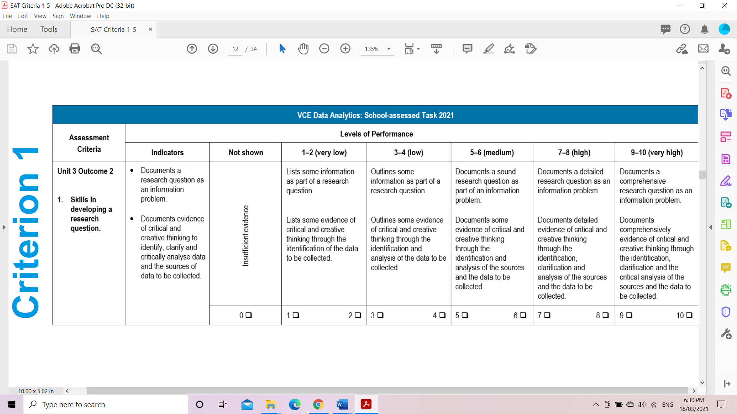

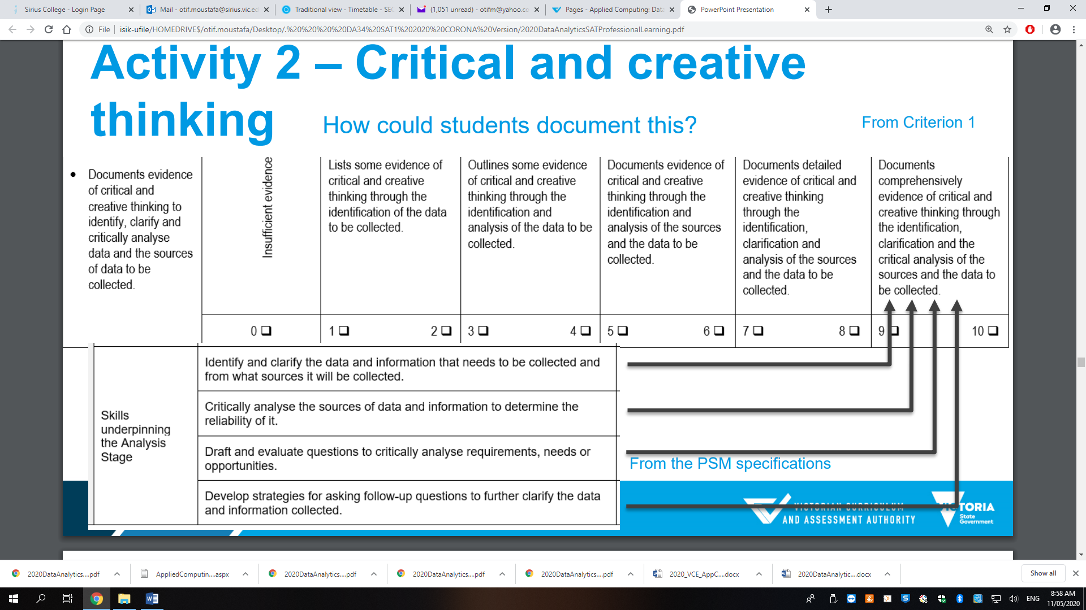

**TASK 1 - C1: Complete the following table for Criteria 1 (Activity 1):**

|  |  |  |  |
| --- | --- | --- | --- |
| 1. **I will research and investigate the following topic in my SAT:** | Research topic: Industrial pollution of heavy metals in fresh water ponds affecting fish ability to reproduce/continue to exist.  Research question: | | |
| 1. **Why did you choose this topic for your SAT?**   **Explain this with referencing to academic research/readings you have done about your chosen topic.** |  | | |
| 1. **Primary Data collection:**   I intend to implement the following data collection methods and strategies:  *(be as specific, precise and detailed as possible in your description)*  **Min 2 sources** | Data source: | How data will be collected and stored? | Why did you choose this method? Explain. |
|  |  |  |
|  |  |  |
|  |  |  |
| 1. **Secondary Data collection:**   I intend to implement the following data collection methods and strategies:  *(be as specific, precise and detailed as possible in your description)*  **Min 3 sources** | Data source: | How data will be collected and stored? | Why did you choose this data source? Explain your reasons. |
|  |  |  |
|  |  |  |
|  |  |  |
|  |  |  |

**TASK 2: SAT Criterion 2 - Project Management**

• Prepares a Gantt chart using software that documents all stages and activities of the problem-solving methodology for U3 O2 and U4 O1.

• Documents all the relevant tasks, sequencing, time allocations, milestones, dependencies and critical path.

**Instructions:** Identify all the tasks required for SAT Part 1 and 2 and enter these tasks to your chosen Gantt software, please choose a

software that allows you to print or download your Gantt Chart.

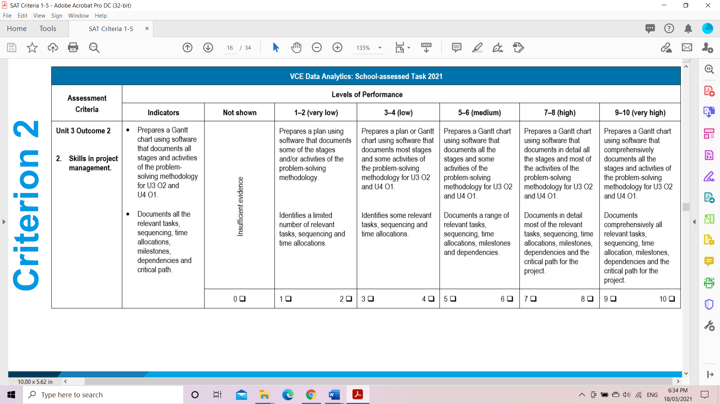

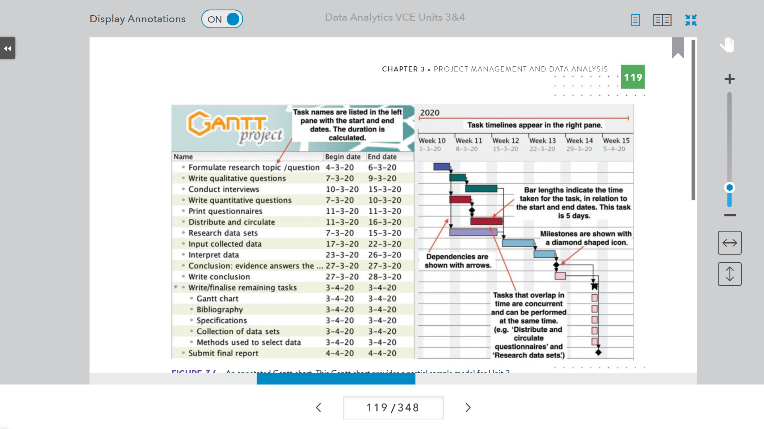

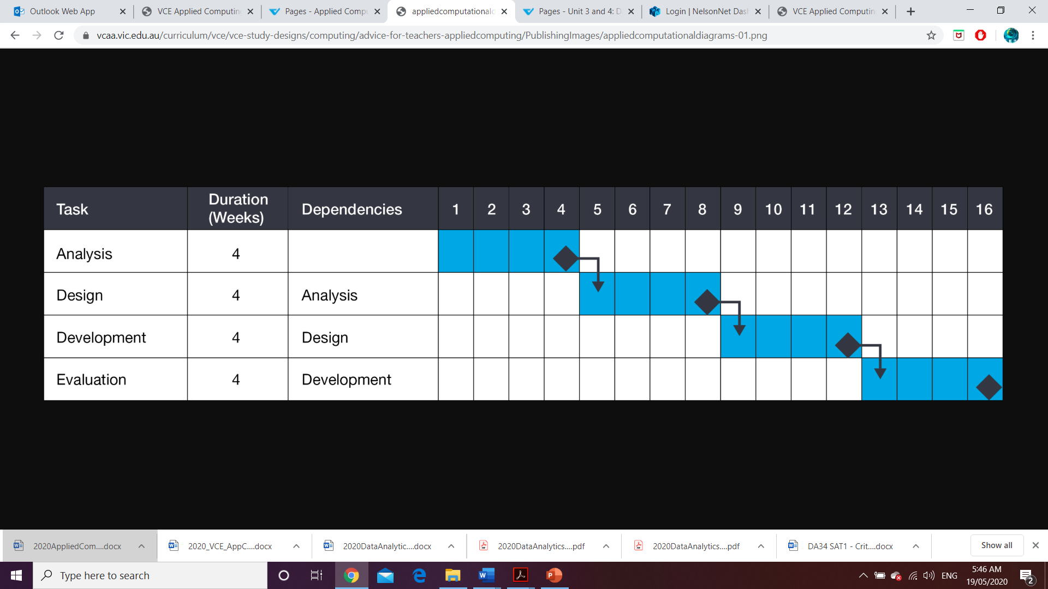

**SAT Criterion 3: Documenting Analysis.**

• Documents the data used to support the research question.

• Documents the functional and non-functional requirements, constraints, and scope.

• Documents evidence of critical and creative thinking through questions and strategies to critically analyse solution requirements.

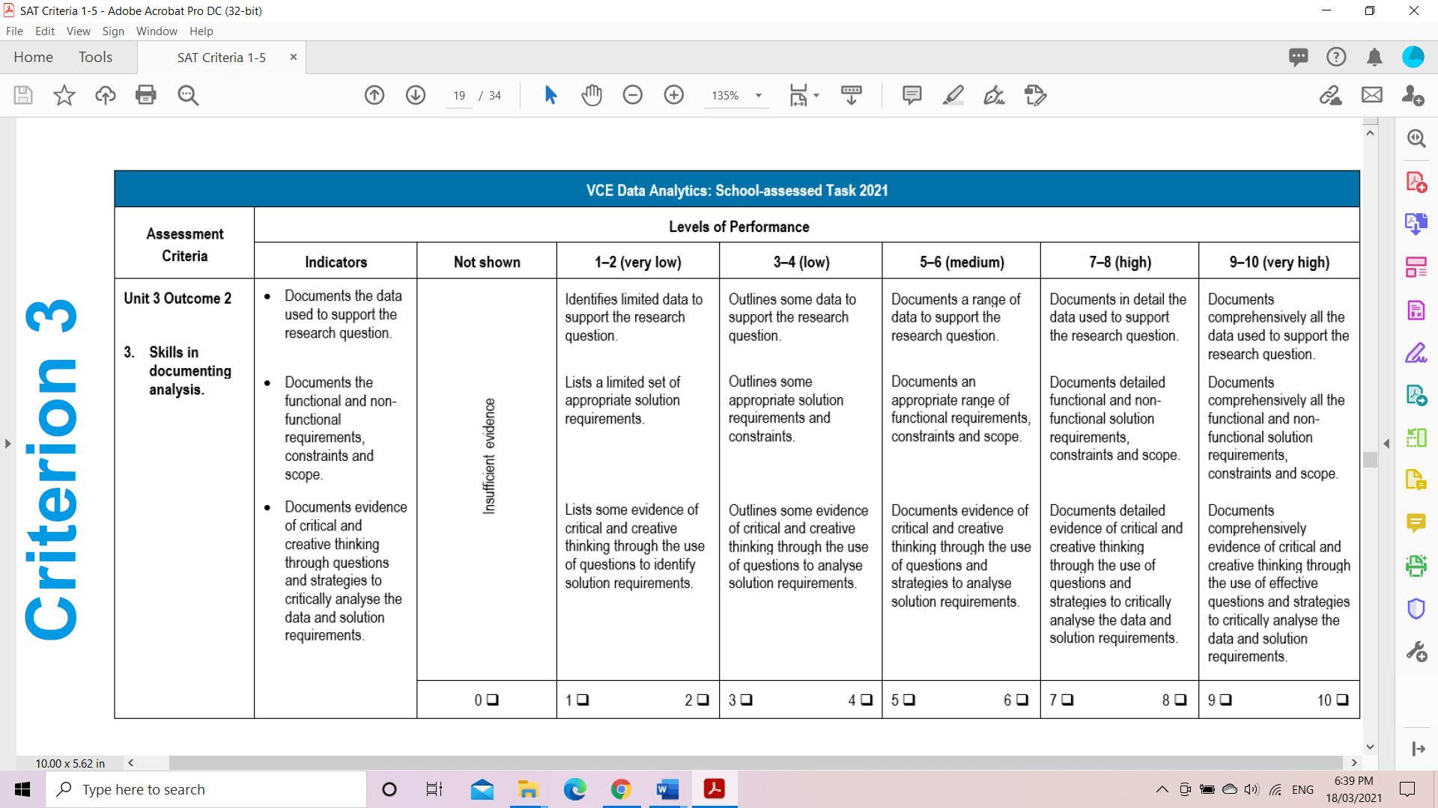

**Activity 3: Complete the following activities for this criterion.**

1. **Document the data to be used to support the research question.**

**Instructions:** Document your analysis to clearly outline the use of data to support the research question for the proposed infographics or dynamic data visualisations.

|  |  |  |
| --- | --- | --- |
| **Your Research topic:** | | |
|  | **Research questions** | **List the primary and secondary data to support each question.** |
| **Write a driving question (Main Research question)** |  |  |
| Supporting question 1 |  |  |
| Supporting question 2 |  |  |
| Supporting question 3 |  |  |
| Extra Notes |  |  |

1. **Analysis of your Research Project - Report**

**Instructions:** In your documentation make sure you create statements of functional and non-functional requirements, constraints, and scope. Please use the following table to guide you to complete the analysis stage of your SAT.

|  |  |
| --- | --- |
| Solution requirements | List all the Solution Requirements according to |
| Determine the functional requirements of the solution. These describe what the software solution should do. This involves specific details such as input required, output developed and functions of the solution including data manipulation and validation. |
| Determine the non-functional requirements. These describe the quality attributes of the solution. These include usability, reliability, portability, robustness and maintainability of project solution. |
| Use tools to assist in determining solution requirements, including context diagrams, data flow diagrams and use case diagrams. |
| Solution constraints | Solution constraints can be described as the conditions or limitations that  must be taken into account when researching and designing your solution. |
| Determine the constraints of the solution. These include economic, such as cost and time; technical, such as speed of processing, capacity, availability of equipment, compatibility and security; social, such as level of expertise of users; legal, such as ownership and privacy of data requirements; and usability, such as usefulness and ease of use of solutions. |
| Solution scope | Solution scope describes the boundaries or parameters of the solution. |
| Identify what will be and/or what will not be addressed by the solution. |
| Skills underpinning the Analysis Stage | Identify and clarify the data and information that needs to be collected and from what sources it will be collected. |
| Critically analyse the sources of data and information to determine the reliability of it. |
| Draft and evaluate questions to critically analyse requirements, needs or opportunities. (Draft your survey/interview etc. data collection questions) |
| Develop strategies for asking follow-up questions to further clarify the data and information collected. |

From PSM Applied Computing Study Design 2025-2028

**SAT Criterion 4**: **Skills in data collection**

• Acquires data sets from primary and secondary data sources.

• Prepares data for manipulation and uses data types and data structures.

• References primary and secondary data using the APA referencing system.

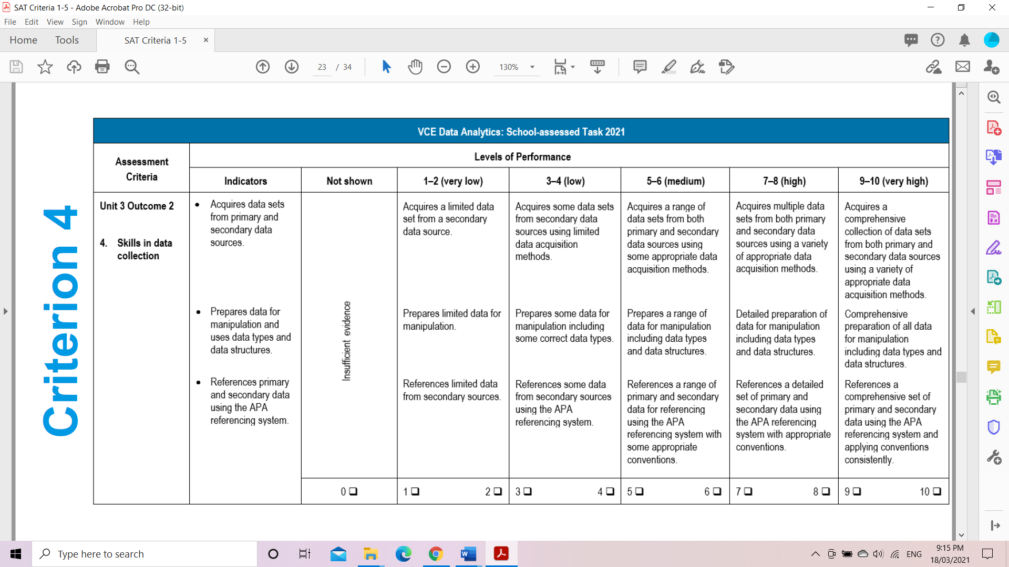

**Activity 4: Task Checklist for Criterion 4**

**Task Instructions:** Students are required to collect data that will inform the analysis of their research question.

Data collection should include a range of methods and techniques, including ***interviews***, ***observation***, ***querying of data stored in large repositories*** and ***surveys****.*

|  |  |  |
| --- | --- | --- |
| **Task** | **Completed** | **NA** |
| 1. **Plan/update your primary data collection methods or techniques.** | | |
| * Finalise your interview questions |  |  |
| * Finalise/update your Survey questioners |  |  |
| * Plan your any other primary data collection tool. |  |  |
| * update your follow up questions |  |  |
| * Prepare your consent form according to your primary data collection tool. |  |  |
| * Prepare your privacy statement according to your data collection method |  |  |
| 1. **Conduct your interviews or surveys etc. to collect your primary data.** |  |  |
| 1. **Collect your data from secondary data sources and securely save your secondary data.** |  |  |
| 1. **Prepare your both primary and secondary data for manipulation by using spreadsheet or database software.** |  |  |
| 1. **Prepare/update your reference sheet in a word document to References primary and secondary data using the APA referencing system.** |  |  |

**Criterion 5**: **Skills in designing the infographics or dynamic data visualisations.**

• Generates alternative design ideas.

• Develops evaluation criteria with reference to design ideas and infographics or dynamic data visualisations.

• Produces preferred designs for infographics or dynamic data visualisations.

• Document evidence of critical and creative thinking through design ideas, solution requirements and justification of preferred designs.

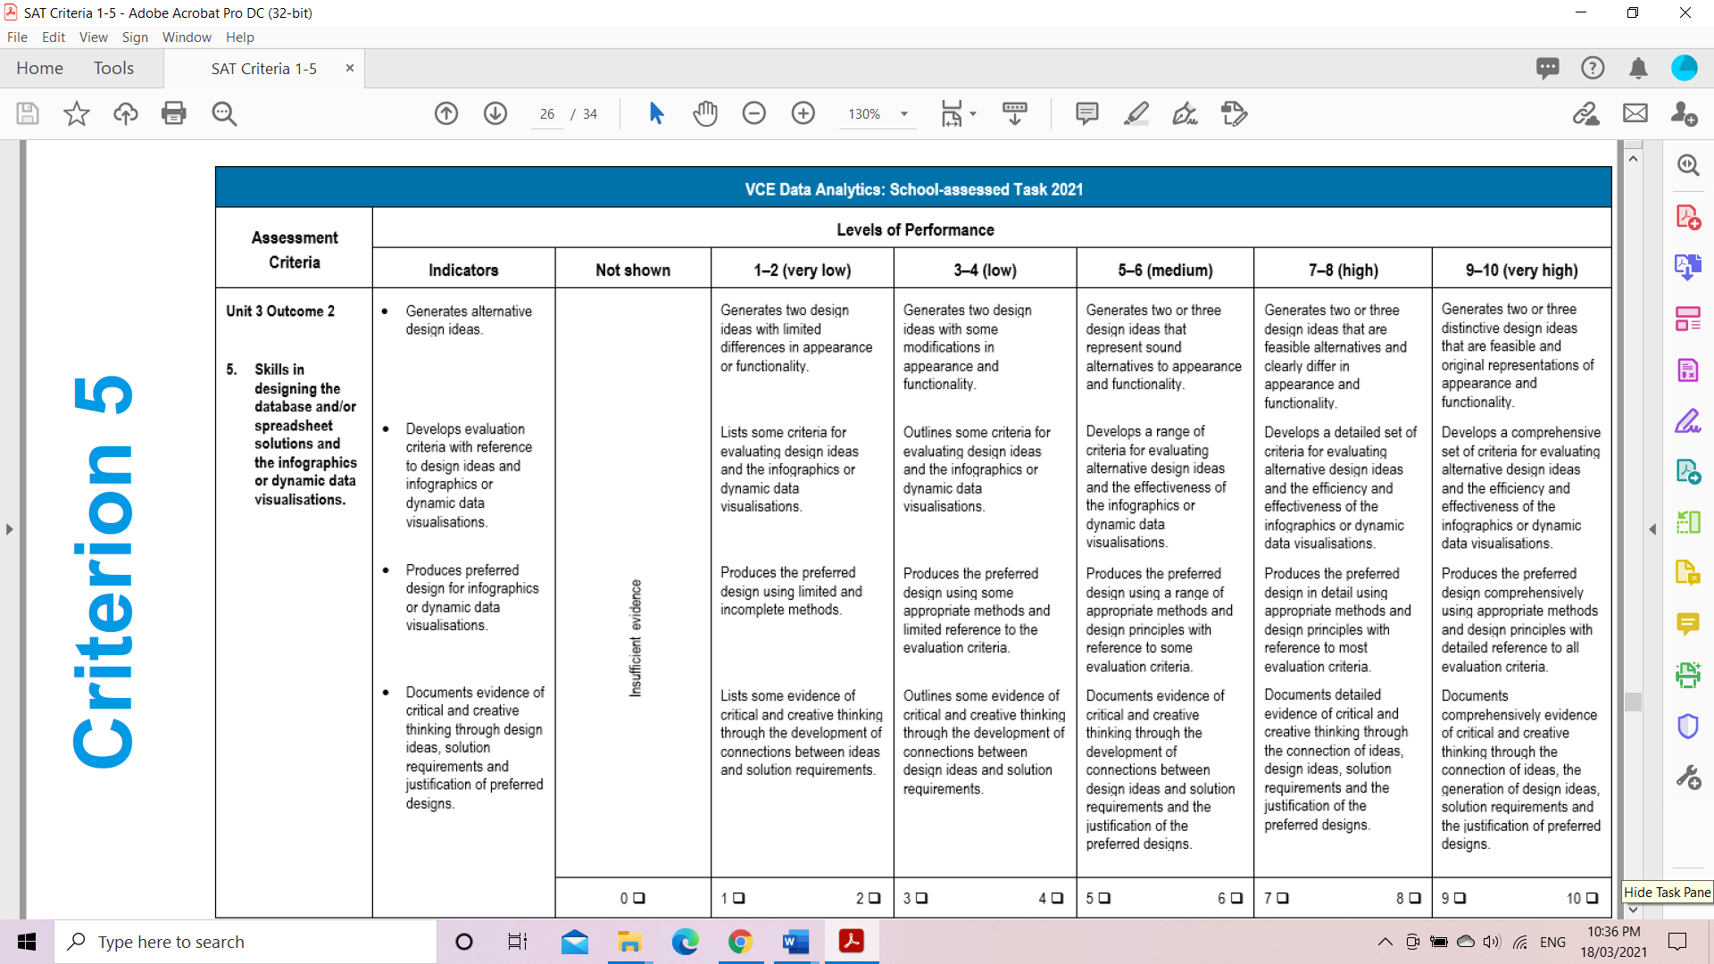

**Task 5: Design Folio:** The design stage of the problem-solving methodology requires students to develop evaluation criteria, generate alternative designs and develop and justify preferred designs.

**Activity 5.1: Create a design folio of 3 alternative design ideas for your infographic or dynamic data visualisation.**

* Your design ideas should be broad in nature and consider the appearance of the infographics or the appearance and functionality of the dynamic data visualisations.
* Your design ideas may include layout diagrams, data dictionaries, storyboards and annotated mock-ups.
* Apply the design principles that influence the design of the infographic or dynamic data visualisations.

**Activity 5.2: Develop Evaluation Criteria**

**Instructions:** You need to develop evaluation criteria that will be used to evaluate your design ideas and in Unit 4 Outcome 1, your proposed infographics, or dynamic data visualisations.

**Evaluation criteria for design ideas can include:**

* The appearance of the proposed infographics or the **appearance** and **functionality** of proposed dynamic data visualisations.
* The evaluation criteria should reference the **functional** and **non-functional** requirements in the analysis and the **effectiveness** of the proposed infographics or dynamic data visualisations.
* The evaluation criteria should be used to determine and justify which of the design ideas should be further developed into detailed designs.
* The detailed designs should be representative of how the proposed infographics or dynamic data visualisations will **appear** or **function**.

Below is a process for developing detailed designs.

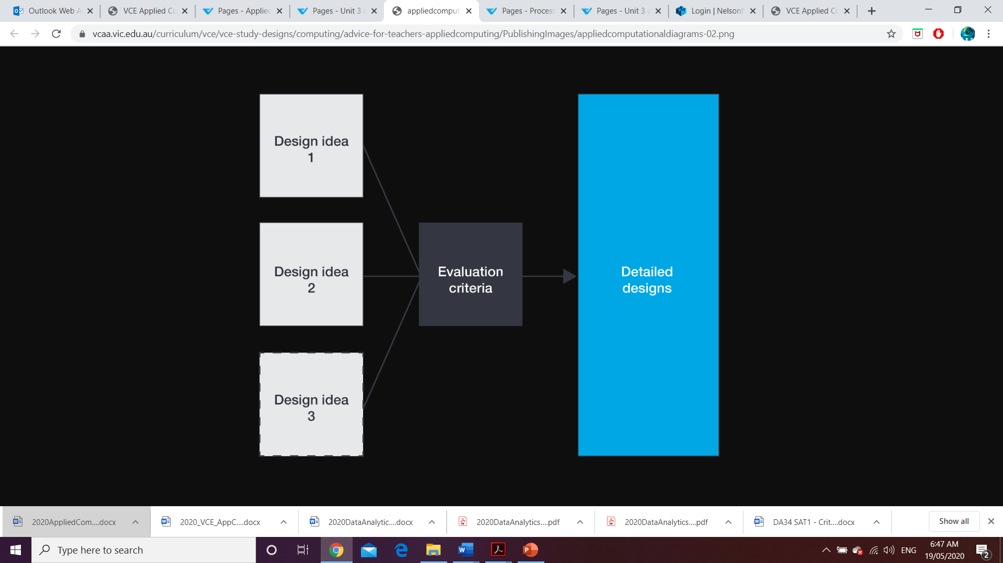

**Note 1:** Preparation for future testing should be considered by students in line with the problem-solving methodology recommendations for the solutions. Please refer to the following PSM table when completing activities for Criterion 5.

|  |  |  |
| --- | --- | --- |
| **Design Stage of PSM:** The Design Stage involves determining how the solution requirements will function and  appear. It involves developing evaluation criteria; designing the functionality, appearance and user  interface of the solution; and designing the tests to ensure that requirements can be met. | | |
|  | Solution design | Design how the solution will function and appear by identifying the specific data required and how it will be named, structured, validated and manipulated. |
| Use design tools, including data dictionaries, input–process–output (IPO) charts, object descriptions and pseudocode. |
| Use design tools to show the relationships between the components of a solution, including storyboards, site maps, structure charts, context diagrams and data flow diagrams. |
| Design the visual components of the solution, including the user interface, reports and any graphic representations or data visualisations generated. |
| Identify the position and size of text, images and graphics, font types and styles, colours and text enhancements. |
| Use design tools, including layout diagrams, annotated diagrams and mock-ups. |
| Design tests to ensure the solution will achieve what it is intended to do. |
| Determine what tests need to be performed, what test data needs to be included and the expected result after the test is conducted. |
| *Note that testing of the actual solution as it is developed is performed during  the Development Stage*. |
| Skills underpinning the Solution design activity | Investigate possible solutions and develop connections between ideas. |
| Use a range of techniques to generate a range of alternative solutions designs. |
| Create and connect initial design ideas using text and diagrams. |
| Determine possible contingencies when developing solution designs to mitigate issues. |
| Evaluation criteria | Develop evaluation criteria to determine the degree to which solution designs meet requirements. Evaluation criteria measure the efficiency and effectiveness of the designs. |
| *Note that the same evaluation criteria are used in the Evaluation Stage to  determine the degree to which the solution meets requirements. The  evaluation criteria, in the Evaluation Stage, measure the efficiency and  effectiveness of the solution*. |
| Modify and refine the evaluation criteria as the solution develops. |

**Important reminder: Managing the project throughout Unit 3 Outcome 2**

The activities in this area of study need to be managed by the student as part of their project plan, which requires the use of monitoring their progress in order to remain on track with meeting all the identified milestones throughout the School-assessed Task

